## **Resources**

I have made a [Google Drive folder](https://drive.google.com/open?id=1XaxSQ_2_lNgaTxlwC8si9PQ93d35RERa) within which I will try to keep all the resources required for the tutorial. Within it, you will find:

* An [Installers](https://drive.google.com/open?id=1o_ztEOK-wMVExM_o1ti_XAPYPzjxOIoe) folder within which I’ve placed some installation files you might use.
* A [Videos](https://drive.google.com/open?id=1SmeCeRxP0ru1apAZ_sz76iegrmT1DiAv) folder where I will try to place the recorded videos after each session.
* A [Google Doc](https://docs.google.com/document/d/1573KqDJ183OZPMJNzlQviq3VcvDnfr09bWautjm7Sy4/edit?usp=sharing) with important links and the schedule.
* The blank Jupyter Notebooks in a [zipped file](https://drive.google.com/open?id=1QBe3HLaK6PWDA8UBZ310qAVTenFRZf60). → **Download this file and unzip it.**
  + I would suggest that this file be unzipped on your **Desktop**. This is only because it is easy to get to from Jupyter notebook. You may choose any other folder, but you will need to know how to navigate to it after you’ve installed Jupyter (see below).

## **Installing software**

### Slack

We will be using Slack to communicate. You can either download Slack (for [Windows](https://slack.com/downloads/windows), [Mac](https://slack.com/downloads/mac), or your phone), or alternatively use it online. You should all have been invited to the [Slack channel](https://pyar-workshop.slack.com/messages/CDMR8FZAQ/) by Raja. Make sure you can access the ***#general*** channel, where updates will be posted.

### Zoom

Zoom can also be downloaded on your computers (from [here](https://zoom.us/download#client_4meeting)). You don’t need an account to access the conference [link](https://ucsc.zoom.us/j/985270755) (the id meeting id is ***96790222788***). If you’re calling from an area that risks being noisy, it might be a good idea to **mute** yourself, and only unmute when you want to speak.

### Anaconda Python

Anaconda is an open-source distribution for programming in Python (among other things). Installing it will install Jupyter Notebook, an open-source web application which will allow you to create, edit and run Python code. Please download the ***Python 3.7 or 3.8 version*** from here:

1. [Windows (64 bit)](https://www.anaconda.com/download/#windows): Most newer windows computers are 64 bit, but if you need to find out if yours is, you can use the methods [here](https://support.microsoft.com/en-in/help/827218/how-to-determine-whether-a-computer-is-running-a-32-bit-version-or-64). Otherwise, download the [installer for 32 bit](https://repo.anaconda.com/archive/Anaconda3-5.3.0-Windows-x86.exe).
2. [Mac](https://www.anaconda.com/download/#macos)
3. [Linux](https://www.anaconda.com/download/#linux)

Installation instructions can be found for [Windows](https://docs.anaconda.com/anaconda/install/windows/), [Mac](https://docs.anaconda.com/anaconda/install/mac-os/), and [Linux](https://docs.anaconda.com/anaconda/install/linux/). I would suggest installing Microsoft VS Code during the installation. Remember, you need to install the **Python 3.7 version**.

***Important***: The download and installation of Anaconda will take a significant amount of time (over 30 minutes, at least). To save time **make sure it’s done before the tutorials begin**.

Once this is done, you can open the start menu and look for Anaconda. If the installation succeeded, you should find the **Anaconda Navigator** there: click it, and wait for it to open. If this doesn’t work, you may need to perform the installation again.

## 

## **Getting started**

Once the navigator is open:

1. ***Launch*** Jupyter Notebook ( **not** JupyterLab ), which should open in a new browser, with a tab that looks like this:

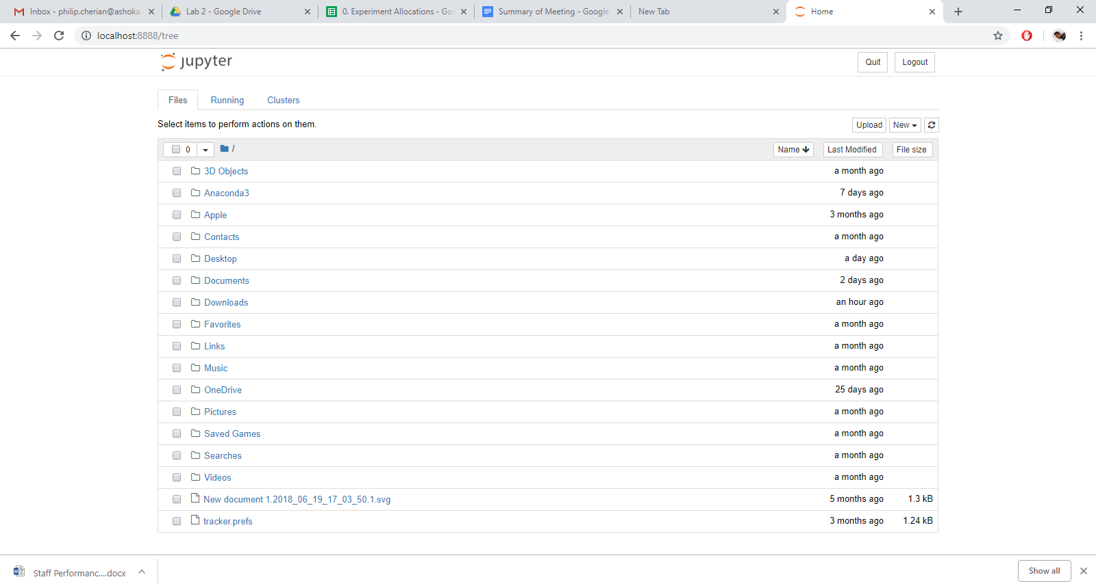

1. Navigate to the folder when you extracted the earlier [zipped file](https://drive.google.com/open?id=1QBe3HLaK6PWDA8UBZ310qAVTenFRZf60) with the blank notebooks. In my case, it is on the **Desktop**, so I navigate to:   
   ***Desktop → 5. JupyterNotebooksBlank → SIP Python Workshop***

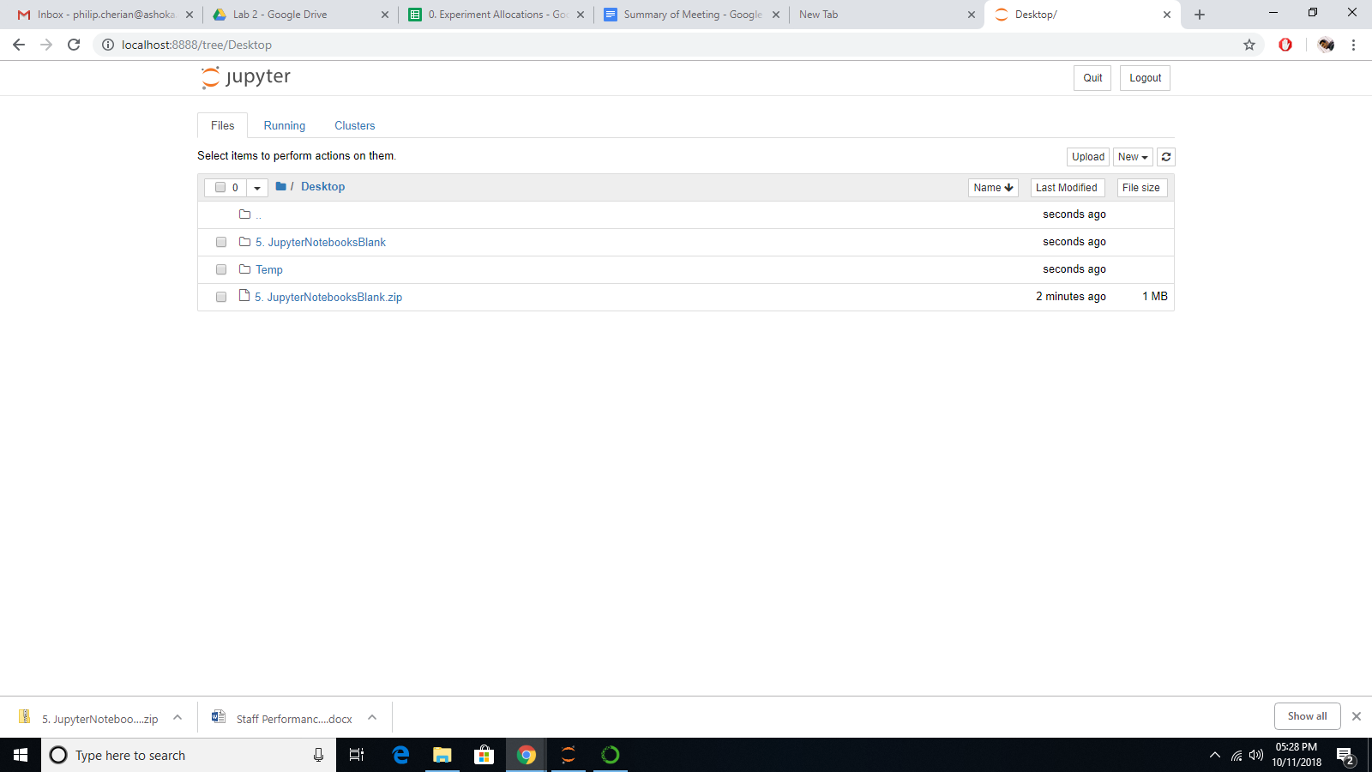

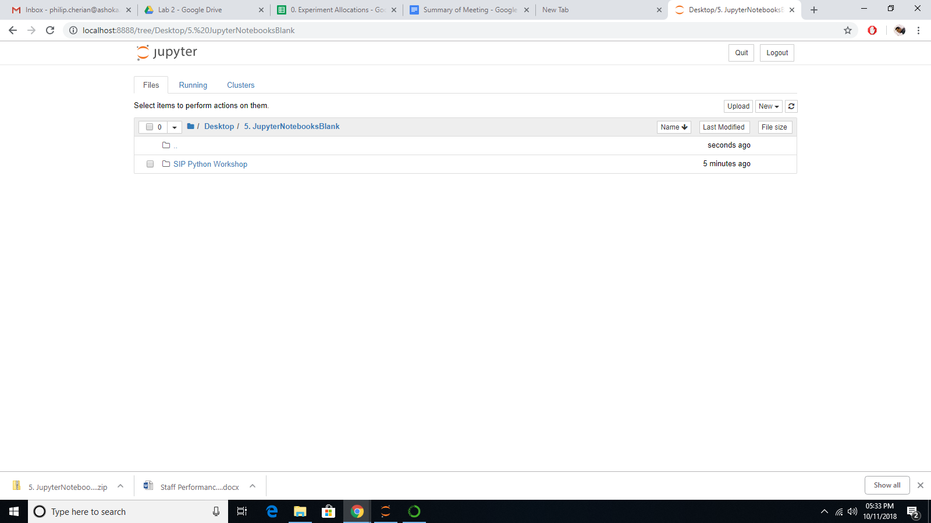

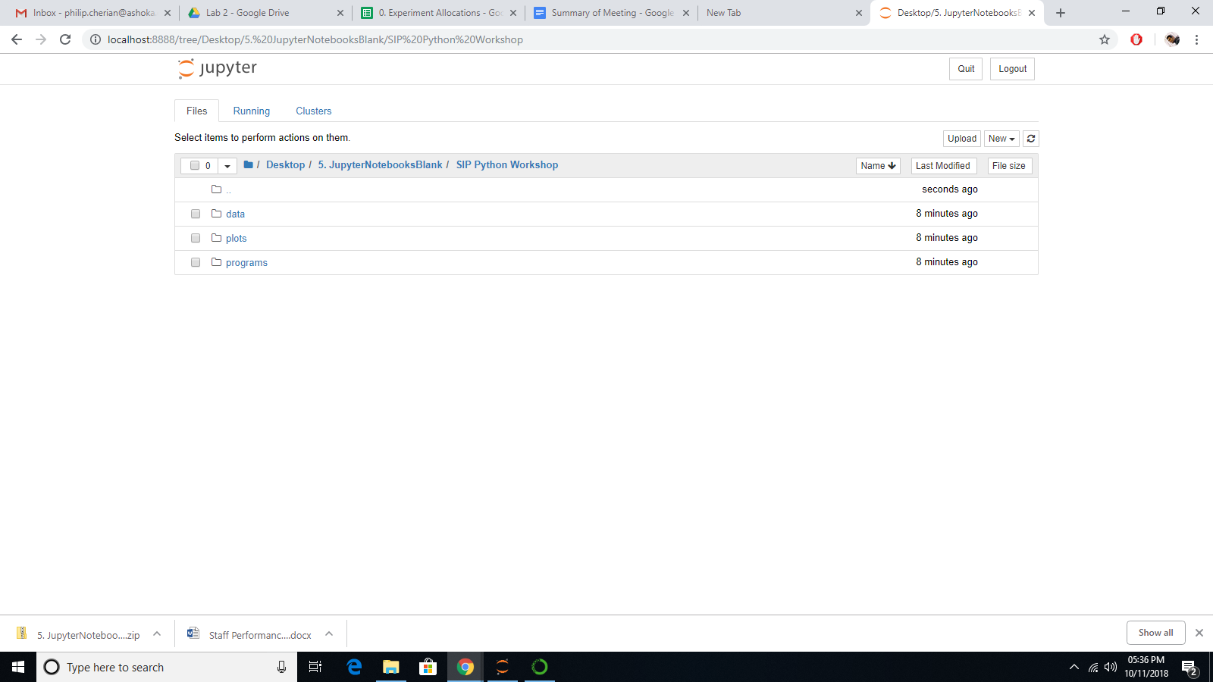

1. You should see three different folders:
   1. The **data** folder contains the Astrophysical data that will be used during the tutorials.
   2. The **plots** folder contains graphs that will be used during the tutorials
   3. The **programs** folder contains the six Jupyter Notebooks that comprise the tutorial.
2. Go to **programs → 1-Python Intro.ipynb**. This will open the first notebook file in a new tab, and you should get something that looks like this:

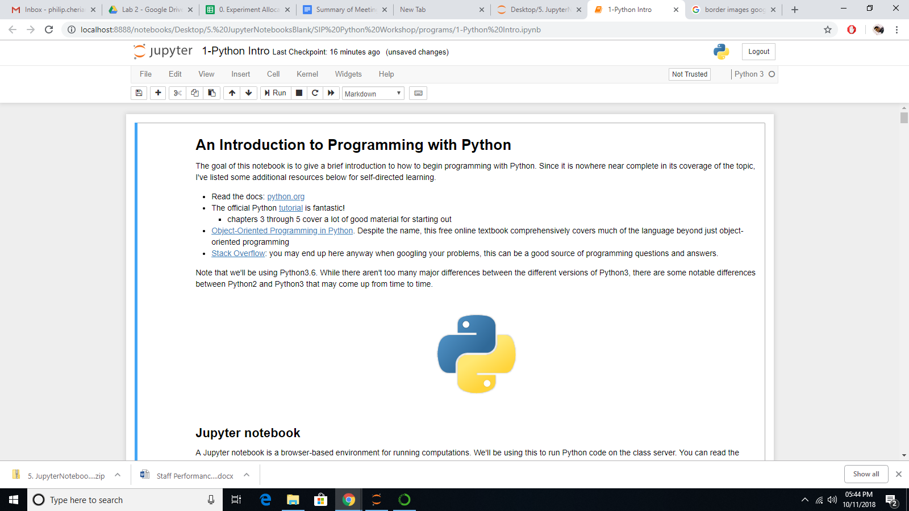

1. Scroll through the notebook. You will see different “blocks” or “cells” of code, all labelled by In[1], In[2], etc. Scrolling down you will see they go up to In[56]i.e., 56 cells. These are the areas where you can input lines of code. For example, consider the first:

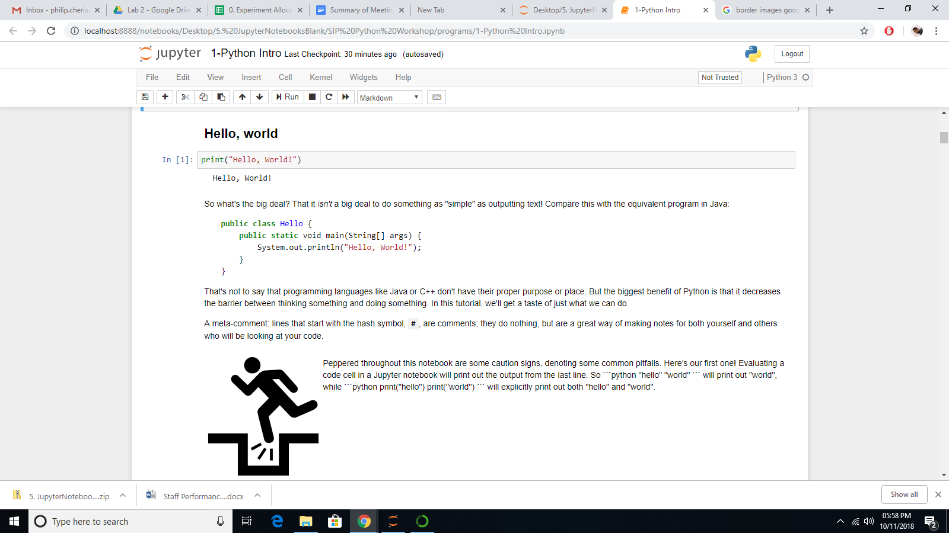

The command is simple. You are asking python to print out a String (which is placed in double quotes). Under the cell, you can see the output. You can now go ahead and change the *Hello* to a *Goodbye*, and **run the cell**, by pressing **SHIFT** and **ENTER** simultaneously. You should see the output message change:

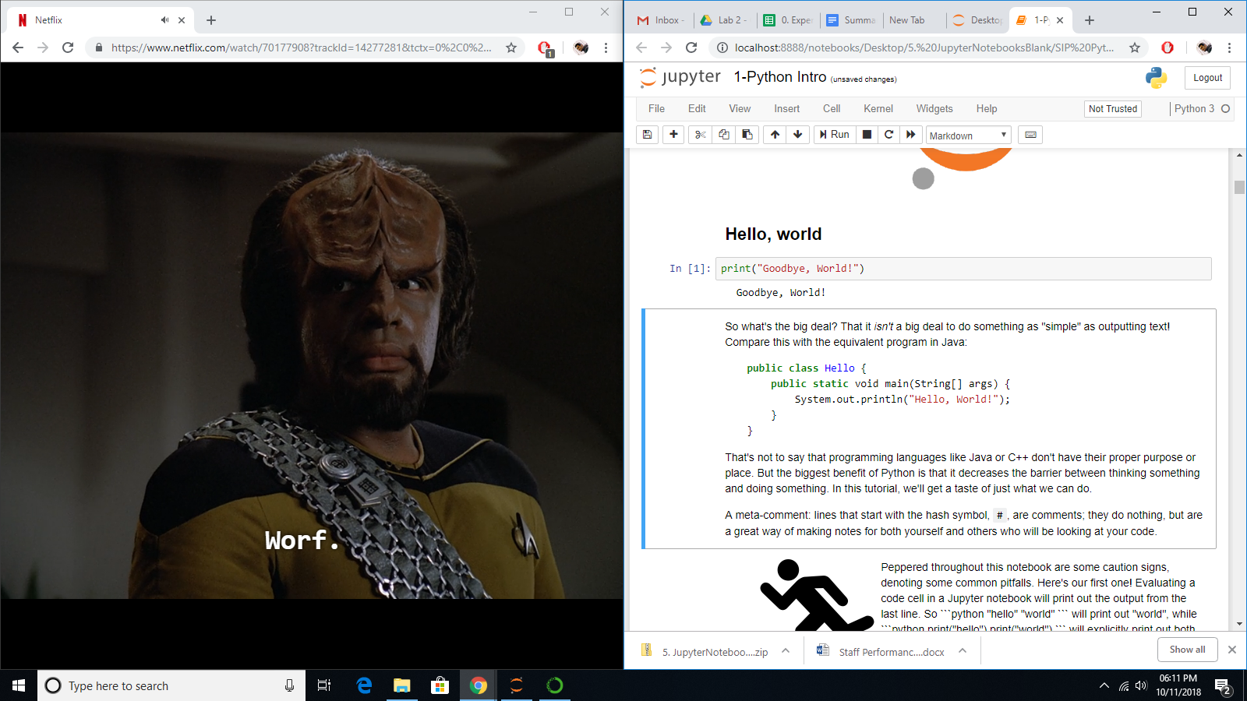

1. Go through the next few input cells which will give you a rudimentary understanding of Python commands.
2. You can now scroll down to In[56]. You should see a graph in the output. This is a scatter plot of some data, and it shows you **three dimensions** of data in a single **two dimensional** plot. Each dot represents a star in the Andromeda galaxy: the position of the dots are given by two angles (the RA and Dec axes of the graph) that **locate** the star, and the **colour** of the dot determines its **brightness.**  
   Look for the line that says marker='o'. Changing the o to a + will change the shape of the point on the graph. You can go ahead and change it so it looks like this:

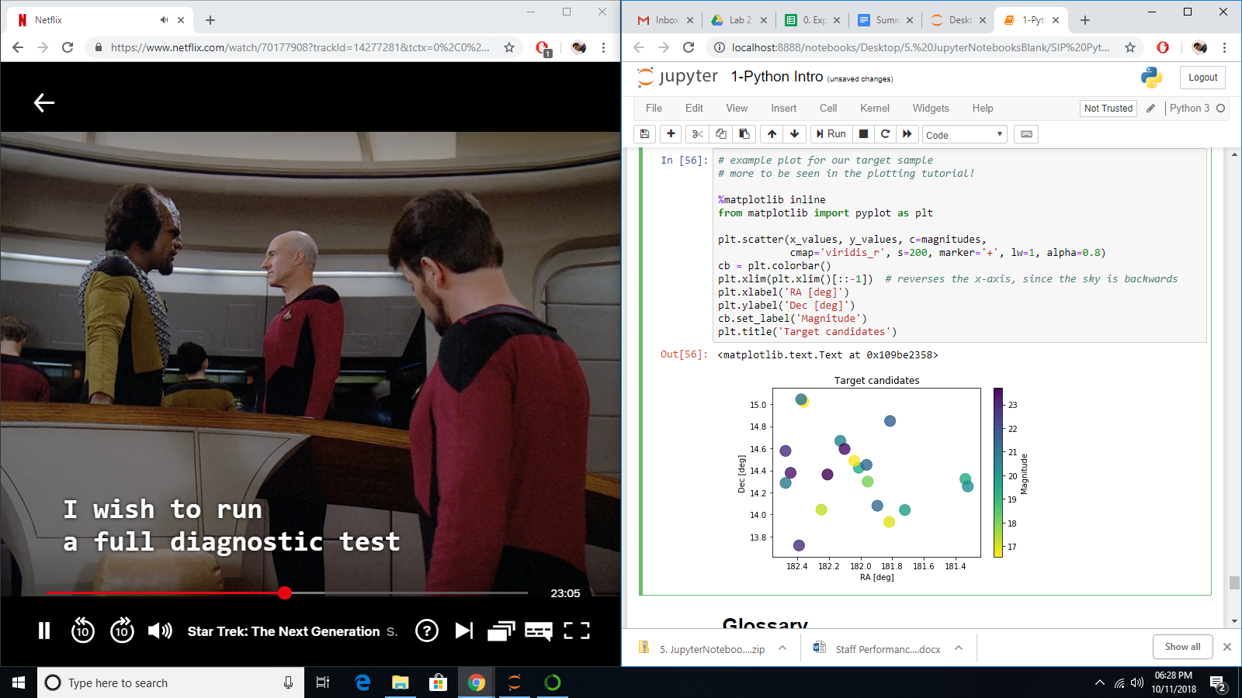

If you try to run this code (by pressing **SHIFT+ENTER**), you might see the graph be replaced by the following error:

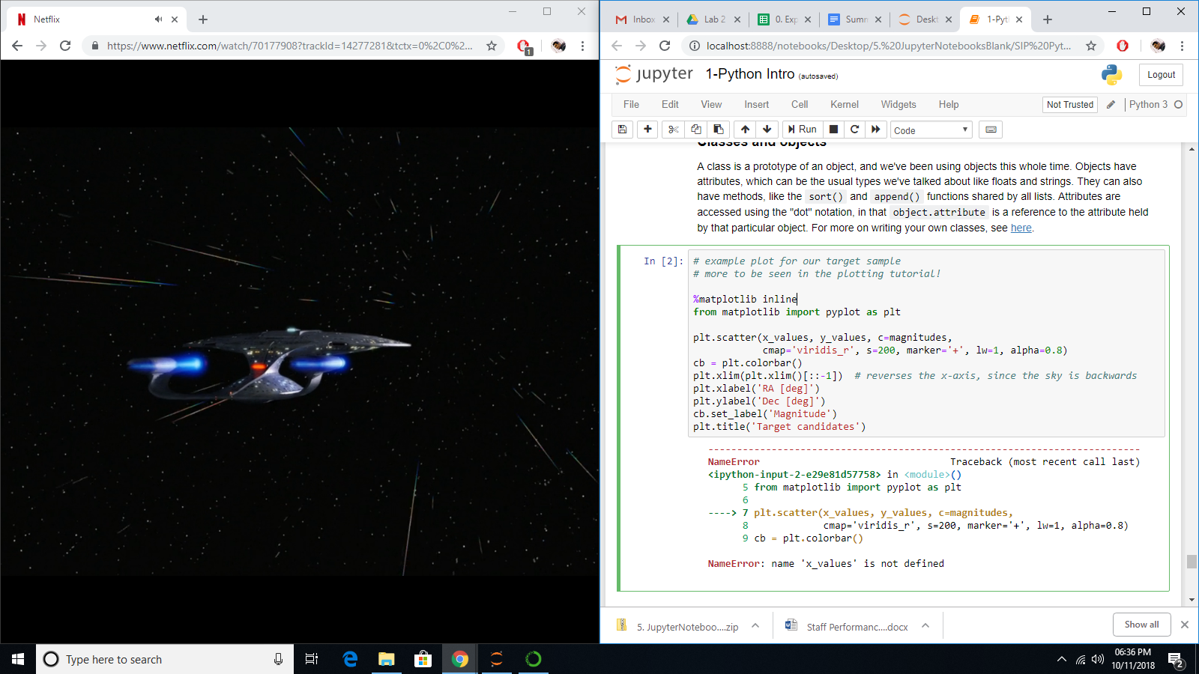

The error has two parts: in the first, it indicates roughly ***where*** the error is (indicated by a **-----> 7**), i.e. it says here that the error is in line **7** of this cell. Under this, we have the actual content of the error: **name ‘x_values’ is not defined**.

1. This error will help us understand Jupyter notebook a little better. The notebook file is made up of individual cells. However, until a cell has been **run**, the information in that piece of code is not “visible” to any other cells.  
     
   In this case, the variable called **‘x_values’** was defined in an earlier cell which has not yet been run. Doing a quick search (**Ctrl + F**) for the first occurence of “x-values” will show it in cell In[50]. Run this cell now (it will not produce any output). Now, if you go back to In[56] and try to run it again, you should see something like this:

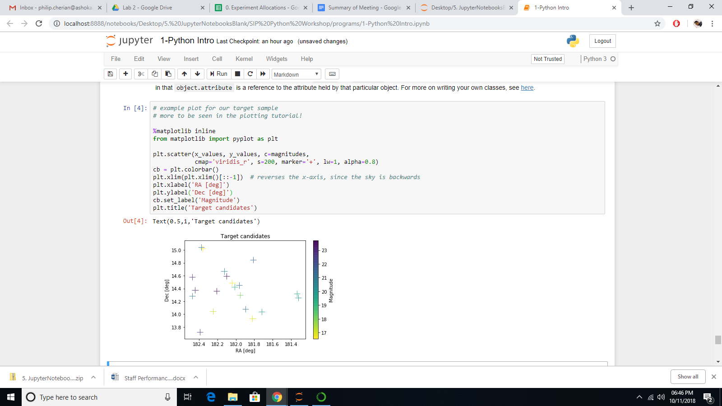

1. Instead of actually manually finding where **‘x_values’** was, you could alternatively just have run the entire notebook, which can be done by going to the **Cell** tab and clicking **Run All**.

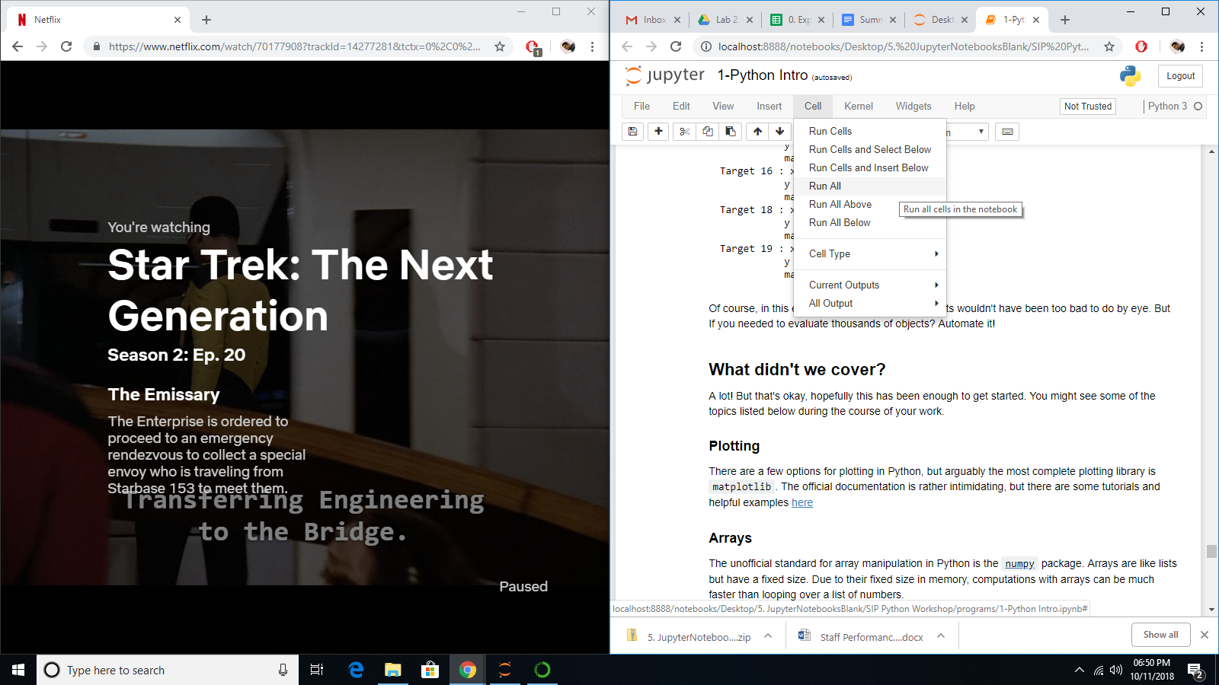

You could alternatively just **Run All Above**, or **Run All Below**.

1. New Cells can be inserted using the **Insert** tab.